**Date: October 15, 2019**

**Subject: MONTHLY AWARDS CEREMONY**

MIAMI POLICE DEPARTMENT

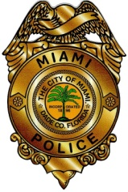

An awards ceremony honoring the Miami Police Department’s officers and employees for the month of September 2019, will be held tomorrow, October 16, 2019, at 10 a.m., in the auditorium of the City of Miami Police College, located at 350 Northwest 2 Avenue.

Chief Jorge Colina will present the following awards: the Civilian Employee of the Month, Silver Lifesaving, the Community Service of the Month, the Community Policing of the Month, the Unit Citation of the Month, and the Officer of the Month.

Members of the media are encouraged to attend.

For more information call the Miami Police Department’s Public Information Office at (305) 603-6420.

**Ofc. Kenia Fallat Cmdr. F. Cruz II**

**N/A**

**October 15, 2019**